Visitor Parking
Locations
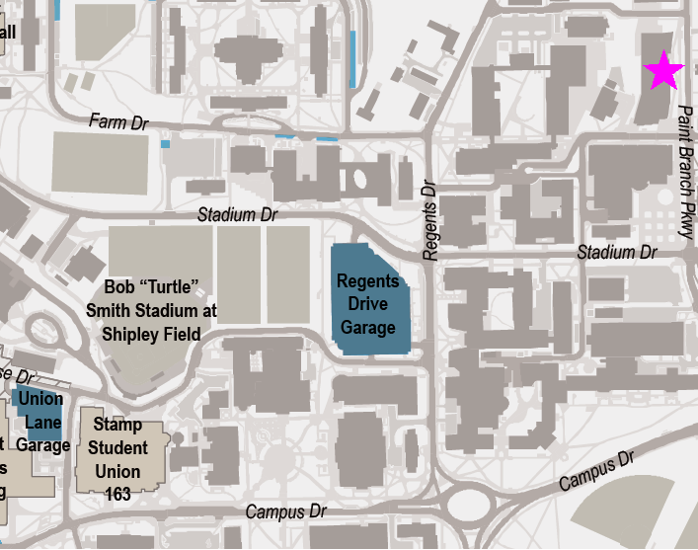
Pink Star is A. James Clark Hall
Union Lane Garage - Located between the Adele H. Stamp Student Union Center for Campus Life and Cole Field House. Hours of operation, as a pay station area, are 7:00a.m. to midnight daily. Current rates at this facility are $3.00 per hour.
Regents Drive Garage – Located near Hornbake Library, the Plant Science, Physics and Chemistry buildings. A small number of visitor parking spaces are available on the south (Fieldhouse Drive) entrance. Hours of operation are 7:00a.m. to midnight daily. Current rates at this facility are $3.00 per hour.
For more visitor parking locations, please refer to this visitor parking map.

